
COMSATS University Islamabad
Department of Computer Science

CSC291 Software Engineering
Semester: Spring 2026
BS(AI) – Section 6

Assignment No.2
Group No 15

Title of the Project
ShareWay

Submitted by:
Syed Muhammad Shahzaib Haider Rizvi
FA23-BAI-050

Arhum Fareed
FA23-BAI-006

Muhammad Awais Ali
FA23-BAI-028

Submission Date:
26 – March – 2026

Project Title: ShareWay - Ai Powered Peer to Peer Ride Sharing Platform

1. Project Overview
Scope
ShareWay is a cross-platform mobile application (Android/iOS) built with Flutter that facilitates peer-to-peer ride-sharing among urban commuters. The system leverages Firebase for its real-time backend and OpenStreetMap services for location and routing. It features an intelligent ride-matching algorithm that scores potential rides based on route similarity, time overlap, driver rating, and proximity connecting passengers with the most suitable drivers. The app supports dual user roles (driver and passenger), real-time messaging, live ride tracking, and multiple Pakistani payment methods (Cash, Easypaisa, JazzCash, Bank Transfer).
Problem Statement
In Pakistani urban centers, daily commuters face rising fuel costs, traffic congestion, and limited affordable transport options. Existing ride-hailing services operate on a commercial driver model, making them expensive for routine commutes. There is no widely adopted platform that allows everyday commuters traveling similar routes to share rides, split costs, and reduce traffic leading to underutilized vehicle capacity, higher per-person travel expenses, and increased carbon emissions.
Objectives
- Develop a Peer-to-Peer Ride-Sharing Platform: Create a functional, cross-platform mobile MVP (using Flutter) that allows drivers to offer spare seats and passengers to find matching rides along their route.
- Intelligent Ride Matching: Implement a weighted scoring algorithm that matches passengers with drivers based on route similarity (40%), time overlap (30%), driver rating (20%), and pickup proximity (10%).
- Real-Time Communication & Tracking: Enable in-app messaging between ride participants and live GPS tracking during active rides.
- Trust & Safety: Build a ratings and reviews system that allows both drivers and passengers to rate each other after completed rides, fostering community trust.
- Cost Transparency: Provide estimated fare calculation (15 PKR/km) with support for multiple local payment methods.
- Offline Resilience: Ensure basic app functionality through Firestore's offline persistence when internet connectivity is intermittent.
System Limitations / Constraints
- Geographic Limitation: Location search and geocoding are constrained to Pakistan using OpenStreetMap Nominatim services.
- No Payment Gateway Integration: The app tracks payment method preferences and transaction records but does not process actual digital payments settlement happens outside the app.
- Hardware Dependency: Real-time tracking and map features require a device with GPS capability and adequate processing power.
- Client-Side Matching: The ride matching algorithm runs on the client device rather than a dedicated server, which may not scale efficiently for a very large user base
- Fare Estimation Only: Fares are estimated at a fixed rate (25 PKR/km) and are not legally binding; actual cost is agreed upon between driver and passenger.

2. UML Use Case Diagram:
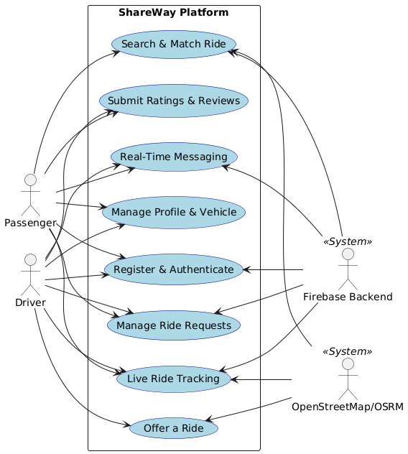

3. Detailed Use Cases:
Use Case 1: Offer a Ride
Use Case ID: | UC-3.1
Use Case Name: | Offer a Ride
Actors: | Driver (Primary), OpenStreetMap/OSRM (Secondary)
Preconditions: | 1. User is authenticated and logged into the application.  2. User has toggled their profile to the "Driver" role.  3. Driver has added vehicle details to their profile.
Postconditions: | 1. A new ride offer is successfully published and stored in the Firebase backend.  2. The ride is available in the search pool for potential passengers.
Normal Flow: | 1. Driver navigates to the "Offer Ride" screen.  2. Driver selects the origin and destination locations on the interactive map.  3. System calculates the route, total distance, and estimated travel time using OSRM.  4. Driver inputs departure date, time, available seats, and accepted payment methods.  5. System calculates the estimated fare based on the fixed rate.  6. Driver confirms and publishes the ride.  7. System saves the ride to the database and displays a success message.
Alternative Flows: | 4a. Route Calculation Fails:  1. In step 3 of the normal flow, if OSRM cannot determine a route, the system prompts the Driver to manually adjust map pins.  2. Driver adjusts pins.  3. Use Case resumes on step 3 of the normal flow.
Exceptions: | 2a. Geographic Constraint Violation:  1. In step 2 of the normal flow, if the selected location is outside Pakistan.  2. System displays an error: "Location must be within Pakistan."  3. Use Case resumes on step 2 of the normal flow.
Includes: | Calculate Route (Common routing functionality).
Quality Requirements: | The interactive map and location selection must be intuitive. Basic offer details must save locally via Firestore persistence if the network drops during setup.

Use Case 2: Search & Match Ride
Use Case ID: | UC-3.2
Use Case Name: | Search & Match Ride
Actors: | Passenger (Primary), OpenStreetMap/OSRM (Secondary), Firebase (Secondary)
Preconditions: | 1. Passenger is authenticated and logged in.  2. Passenger role is selected.
Postconditions: | 1. System displays a ranked list of available rides matching the Passenger's criteria.  2. Passenger can select a ride to view details or send a request.
Normal Flow: | 1. Passenger navigates to the "Find Ride" screen.  2. Passenger enters pick-up and drop-off locations.  3. Passenger specifies desired departure time and number of seats needed.  4. Passenger taps "Search".  5. System queries Firebase for active ride offers.  6. System applies the weighted matching algorithm (40% route similarity, 30% time overlap, 20% driver rating, 10% proximity).  7. System displays the ranked results to the Passenger.
Alternative Flows: | 6a. No Exact Matches Found:  1. In step 6 of the normal flow, if no rides meet the minimum match threshold, the system displays rides that are geographically close but outside the exact time window.  2. System displays a "Showing Nearby Alternatives" message.  3. Use Case resumes on step 7 of the normal flow.
Exceptions: | 5a. Network Connectivity Lost:  1. In step 5, if the app cannot connect to Firebase, the system displays a "No Internet Connection" error.  2. Use Case terminates.
Includes: | Calculate Route.
Quality Requirements: | The matching algorithm must return ranked results within 2-3 seconds of the search query.

Use Case 3: Manage Ride Requests
Use Case ID: | UC-3.3
Use Case Name: | Manage Ride Requests
Actors: | Passenger (Primary), Driver (Primary), Firebase (Secondary)
Preconditions: | 1. A Passenger has successfully found a matching ride (UC-3.2).  2. Both users are logged in.
Postconditions: | 1. Ride request status is updated to "Accepted" or "Rejected" in the database.  2. If accepted, the Passenger is added to the ride's passenger list and seats are updated.
Normal Flow: | 1. Passenger taps "Send Request" on a selected ride.  2. System updates the request status to "Pending" in Firebase.  3. System sends a push notification to the Driver.  4. Driver opens the request and reviews Passenger profile/ratings.  5. Driver taps "Accept".  6. System updates the ride capacity and changes request status to "Accepted".  7. System sends a confirmation push notification to the Passenger.
Alternative Flows: | 5a. Driver Rejects Request:  1. In step 5, Driver taps "Reject".  2. System updates request status to "Rejected".  3. System notifies the Passenger.  4. Use Case terminates.
Exceptions: | 1a. Ride Reaches Capacity Before Request Processing:  1. In step 1, if another passenger books the last seat while this Passenger is viewing the ride, the system blocks the request.  2. System displays "Ride is no longer available."  3. Use Case terminates.
Includes: | None.
Quality Requirements: | Push notifications must be delivered in real-time using Firebase Cloud Messaging.

Use Case 4: Live Ride Tracking
Use Case ID: | UC-3.4
Use Case Name: | Live Ride Tracking
Actors: | Driver (Primary), Passenger (Primary), OpenStreetMap (Secondary)
Preconditions: | 1. A ride request has been accepted.  2. Driver has initiated the "Start Ride" sequence in the app.  3. GPS permissions are granted on both devices.
Postconditions: | 1. The map interface continuously displays the real-time location of the vehicle until the ride is marked "Completed".
Normal Flow: | 1. Driver taps "Start Ride".  2. System begins capturing the Driver's GPS coordinates.  3. System streams coordinates to the Firebase real-time database.  4. Passenger opens the active ride screen.  5. System retrieves coordinates from Firebase.  6. System plots the Driver's location on the OpenStreetMap interface on the Passenger's device.  7. System continuously updates the position until the Driver ends the ride.
Alternative Flows: | None (Standard continuous tracking flow).
Exceptions: | 2a. GPS Signal Lost:  1. In step 2 or during step 7, if the Driver's device loses GPS signal, the system stops updating Firebase.  2. Passenger's screen shows the last known location with a "Signal Lost" indicator.  3. When GPS is restored, Use Case resumes on step 3.
Includes: | None.
Quality Requirements: | Tracking requires adequate device processing power. App should handle brief network drops smoothly.

